Data Ingestion with Lakeflow Connect

LakeFlow Connect
- LakeFlow Connect streamlines data ingestion with simple, efficient connectors that enables you to bring in data from files, cloud storage, databases, enterprise applications, and streaming sources directly into the Databricks Lakehouse - all within a unified, managed platform.
- This makes Databricks source system agnostic.
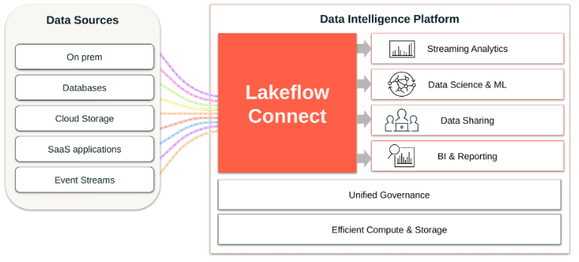
- Key benefit of Lakeflow Connect:
  - Managed and Efficient Solution: Lower costs and quicker time to value
  - Self-Serve Interfaces for Every Practitioner: Democratized data with an accelerated rate of innovation
  - Unified Observability and Governance: Secured and healthy pipelines and tables

LakeFlow Connect Connectors Overview:

Upload Files:
- Upload local files to Databricks
- Upload a file to a volume
- Create a table form a local file

Standard Connectors:
- Supported Sources:
  - Cloud object storage
  - Kafka
  - Other sources
- Ingestion Methods:
  - Batch
  - Incremental Batch
  - Streaming

Managed Connectors:
Ingest data into the lakehouse from:
- SaaS applications
- Databases
- Leverage efficient incremental reads and writes
- Faster, scalable, and more cost efficient

Ingestion Methods

Batch Ingestion:
- Load data as batches of rows into Databricks, often based on a schedule
- Traditional batch ingestion processes all records each time it runs

Common techniques include:
- The SQL statement: CREATE TABLE AS SELECT
- The Python method: spark.read.load()

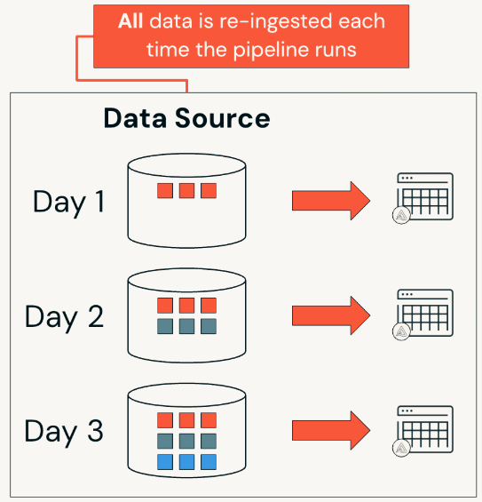
Incremental Batch Ingestion
- Only new data is ingested — previously loaded records are skipped automatically
- Provides faster and more resource-efficient ingestion by processing less data

Common techniques include:
- The SQL statement: COPY INTO
- The Python method: spark.readStream (Auto Loader with a timed trigger)
- Declarative Pipelines: CREATE OR REFRESH STREAMING TABLE
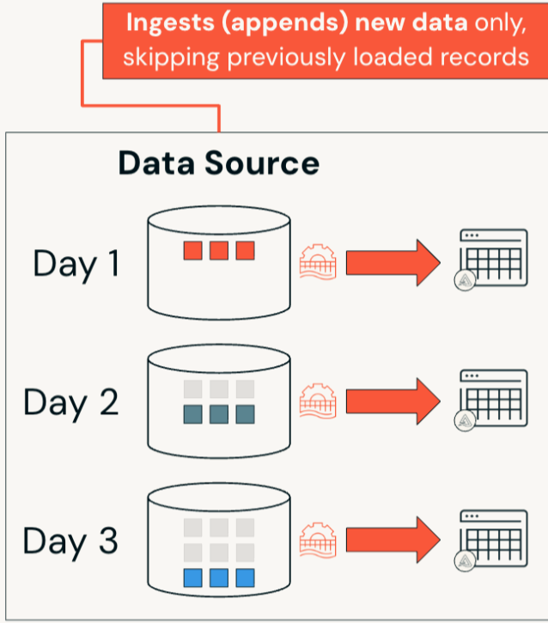
Streaming Ingestion
- Continuously load data rows or batches of data rows as they are generated, so you can query them as they arrive in near real-time
- Micro-batch processes small batches at very short, frequent intervals

Common techniques include:
- spark.readStream (Auto Loader with continuous trigger)
- Declarative Pipelines (trigger mode continuous)

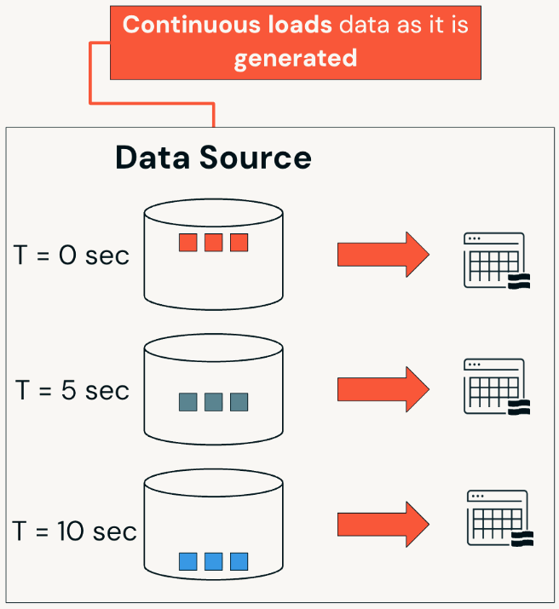
Delta Lake Review

Ingesting Data Into Delta Lake
- Delta Lake is an open-source protocol for reading and writing files to cloud storage.
- The goal is to ingest files from external data sources like cloud object storage into Delta Lake as UC tables.
- UC tables offer an open table format that supports the Lakehouse architecture and storage on AWS, Azure, and GCP cloud data lakes.
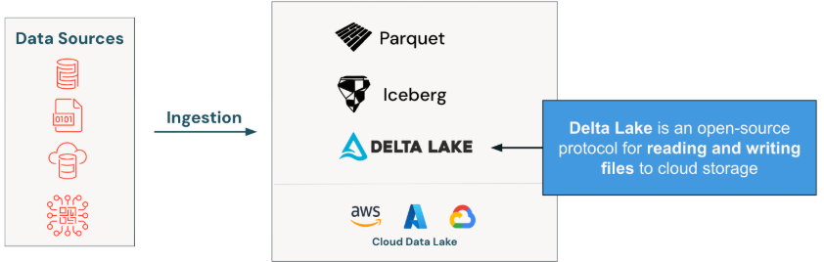
UC table Components Overview
- Data is stored in UC tables.
- Internally, these tables store data as files within a folder directory.
- Data is stored as Parquet files in the directory.
- Delta Lake adds JSON-based Delta logs alongside these files.
- Delta logs track transactions and table versions.

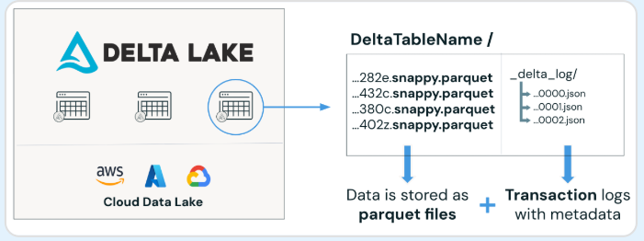
UC Tables Key Features Review

- ACID Transactions: Atomicity, Consistency, Isolation, Durability for all operations, allowing multiple users to read and write data concurrently without conflicts.
- Data Manipulation Language (DML): Supports DML operations such as INSERT, UPDATE, DELETE, and MERGE, enabling flexible data management.
- Time Travel: Allows users to query and revert to previous versions of data, facilitating auditing and recovery.
- Schema Evolution and Enforcement: Enforces a defined schema for data integrity while allowing schema evolution, enabling structural changes without breaking existing workflows.
- Unified batch and streaming processing, optimization and performance, and scalability — and Delta Lake is open source.
Medallion Architecture Review
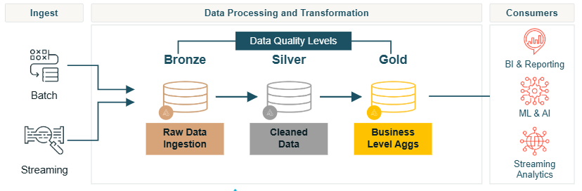
- It begins with Bronze Layer, the raw data ingestion layer. This layer ingest raw, unprocessed data from various source "as is", serving as the foundational storage for all data.
- In the Silver layer, the data is cleaned, transformed, and enriched, providing a more refined dataset that is suitable for analysis.
- Lastly the Gold layer contains curated, aggregated, and high-quality data, optimized for reporting and advanced analytics, often used for business intelligence applications

